[Project Name]
Database Model

Date | [April 12, 2010]
Version | [1.1]
Status | [Approved]
Author | [Nguyen Hoang Son, BA]
Reviewed by | [Le Phi Hung, Project Manager]
Approved by | [Nguyen Thi Thanh Thuy, Director]

Revision History

Date | Version | Description | Author
< May 28> | <1.0> | <Create> | < Le Minh Vuong >
< June 8> | <1.1> | <Update > | < Le Minh Vuong >

Introduction

Purpose

[A description of the persistent data storage perspective of the system.
This view is OPTIONAL if there is little or no persistent data, or the translation between the Design Model and the Data Model is trivial.]

Scope

<Provide a short description of the software being specified and its purpose, including relevant benefits, objectives, and goals. Relate the software to corporate goals or business strategies. If a separate vision and scope document is available, refer to it rather than duplicating its contents here. An SRS that specifies the next release of an evolving product should contain its own scope statement as a subset of the long-term strategic product vision.>

Definitions, Acronyms and Abbreviations

No | Term | Description

References

<List any other documents or Web addresses to which this SRS refers. These may include user interface style guides, contracts, standards, system requirements specifications, use case documents, or a vision and scope document. Provide enough information so that the reader could access a copy of each reference, including title, author, version number, date, and source or location.>

Overview

Data Model Detail

This document provides an overview of the data model. For simpler and more focused reports, simply copy this initial template and turn off the sections not required.

Data model

Type: Package
Package: Implementation Model (PSM)
Detail: Created on 5/11/2005. Last modified on 10/15/2008.
Notes:

DDL
Created By: btxuanngan on 5/11/2005
Last Modified: 4/23/2007, Version:1.0

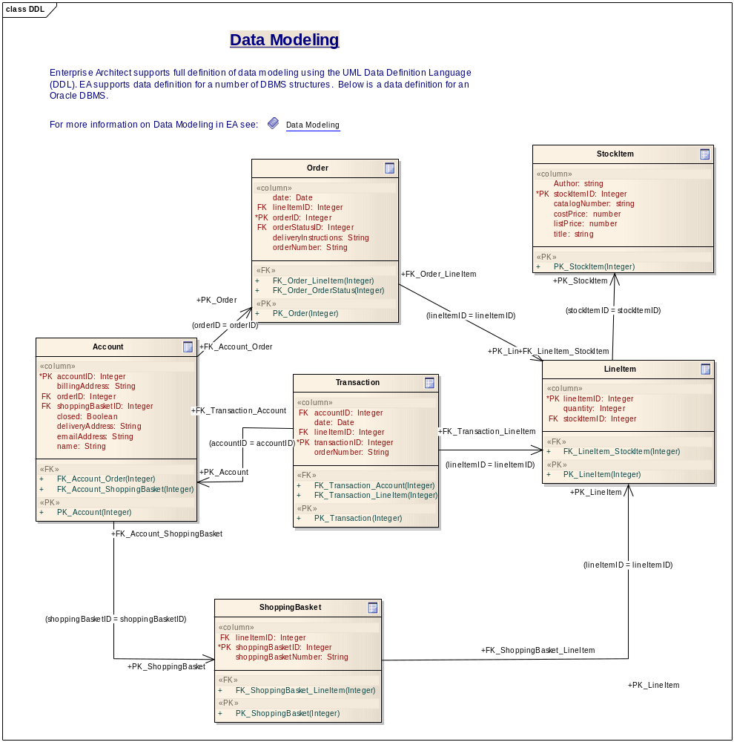
Figure: 1

Account

Database: , Stereotype: «table», Package: Data model
Detail: Created on 5/11/2005. Last modified on 11/30/2005.
Notes:

Columns

PK | Name | Type | Not Null | Unique | Len | Prec | Scale | Init | Notes
True | accountID | Integer | True | False
False | billingAddress | String | False | False
False | orderID | Integer | False | False
False | shoppingBasketID | Integer | False | False
False | closed | Boolean | False | False
False | deliveryAddress | String | False | False
False | emailAddress | String | False | False
False | name | String | False | False

Constraints

Name | Type | Columns | Initial Code | Notes
FK_Account_Order | Public | orderID
FK_Account_ShoppingBasket | Public | shoppingBasketID
PK_Account | Public | accountID

Relationships

Columns | Association | Notes
(shoppingBasketID = shoppingBasketID) | Account.FK_Account_ShoppingBasket  ShoppingBasket.PK_ShoppingBasket
(orderID = orderID) | Account.FK_Account_Order  Order.PK_Order
(accountID = accountID) | Transaction.FK_Transaction_Account  Account.PK_Account

LineItem

Database: , Stereotype: «table», Package: Data model
Detail: Created on 5/11/2005. Last modified on 11/30/2005.
Notes:

Columns

PK | Name | Type | Not Null | Unique | Len | Prec | Scale | Init | Notes
True | lineItemID | Integer | True | False
False | quantity | Integer | False | False
False | stockItemID | Integer | False | False

Constraints

Name | Type | Columns | Initial Code | Notes
FK_LineItem_StockItem | Public | stockItemID
PK_LineItem | Public | lineItemID

Relationships

Columns | Association | Notes
(lineItemID = lineItemID) | Transaction.FK_Transaction_LineItem  LineItem.PK_LineItem
(lineItemID = lineItemID) | Order.FK_Order_LineItem  LineItem.PK_LineItem
(stockItemID = stockItemID) | LineItem.FK_LineItem_StockItem  StockItem.PK_StockItem
(lineItemID = lineItemID) | ShoppingBasket.FK_ShoppingBasket_LineItem  LineItem.PK_LineItem

Order

Database: , Stereotype: «table», Package: Data model
Detail: Created on 5/11/2005. Last modified on 11/30/2005.
Notes:

Columns

PK | Name | Type | Not Null | Unique | Len | Prec | Scale | Init | Notes
False | date | Date | False | False
False | lineItemID | Integer | False | False
True | orderID | Integer | True | False
False | orderStatusID | Integer | False | False
False | deliveryInstructions | String | False | False
False | orderNumber | String | False | False

Constraints

Name | Type | Columns | Initial Code | Notes
FK_Order_LineItem | Public | lineItemID
FK_Order_OrderStatus | Public | orderStatusID
PK_Order | Public | orderID

Relationships

Columns | Association | Notes
(orderStatusID = orderStatusID) | Order.FK_Order_OrderStatus  OrderStatus.PK_OrderStatus
(lineItemID = lineItemID) | Order.FK_Order_LineItem  LineItem.PK_LineItem
(orderID = orderID) | Account.FK_Account_Order  Order.PK_Order

OrderStatus

Database: , Stereotype: «table», Package: Data model
Detail: Created on 11/30/2005. Last modified on 11/30/2005.
Notes:

Columns

PK | Name | Type | Not Null | Unique | Len | Prec | Scale | Init | Notes
False | closed | Integer | False | False
True | orderStatusID | Integer | True | False
False | delivered | Integer | False | False
False | dispatched | Integer | False | False
False | new | Integer | False | False
False | packed | Integer | False | False

Constraints

Name | Type | Columns | Initial Code | Notes
PK_OrderStatus | Public | orderStatusID

Relationships

Columns | Association | Notes
(orderStatusID = orderStatusID) | Order.FK_Order_OrderStatus  OrderStatus.PK_OrderStatus

ShoppingBasket

Database: , Stereotype: «table», Package: Data model
Detail: Created on 5/11/2005. Last modified on 11/30/2005.
Notes:

Columns

PK | Name | Type | Not Null | Unique | Len | Prec | Scale | Init | Notes
False | lineItemID | Integer | False | False
True | shoppingBasketID | Integer | True | False
False | shoppingBasketNumber | String | False | False

Constraints

Name | Type | Columns | Initial Code | Notes
FK_ShoppingBasket_LineItem | Public | lineItemID
PK_ShoppingBasket | Public | shoppingBasketID

Relationships

Columns | Association | Notes
(lineItemID = lineItemID) | ShoppingBasket.FK_ShoppingBasket_LineItem  LineItem.PK_LineItem
(shoppingBasketID = shoppingBasketID) | Account.FK_Account_ShoppingBasket  ShoppingBasket.PK_ShoppingBasket

StockItem

Database: , Stereotype: «table», Package: Data model
Detail: Created on 5/11/2005. Last modified on 11/30/2005.
Notes:

Columns

PK | Name | Type | Not Null | Unique | Len | Prec | Scale | Init | Notes
False | Author | string | False | False
True | stockItemID | Integer | True | False
False | catalogNumber | string | False | False
False | costPrice | number | False | False
False | listPrice | number | False | False
False | title | string | False | False

Constraints

Name | Type | Columns | Initial Code | Notes
PK_StockItem | Public | stockItemID

Relationships

Columns | Association | Notes
(stockItemID = stockItemID) | LineItem.FK_LineItem_StockItem  StockItem.PK_StockItem

Transaction

Database: , Stereotype: «table», Package: Data model
Detail: Created on 5/11/2005. Last modified on 11/30/2005.
Notes:

Columns

PK | Name | Type | Not Null | Unique | Len | Prec | Scale | Init | Notes
False | accountID | Integer | False | False
False | date | Date | False | False
False | lineItemID | Integer | False | False
True | transactionID | Integer | True | False
False | orderNumber | String | False | False

Constraints

Name | Type | Columns | Initial Code | Notes
FK_Transaction_Account | Public | accountID
FK_Transaction_LineItem | Public | lineItemID
PK_Transaction | Public | transactionID

Relationships

Columns | Association | Notes
(lineItemID = lineItemID) | Transaction.FK_Transaction_LineItem  LineItem.PK_LineItem
(accountID = accountID) | Transaction.FK_Transaction_Account  Account.PK_Account

